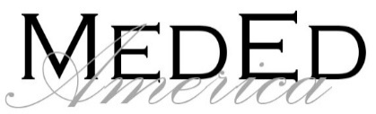

Online Basic Medication Administration Training Registration Form
Please complete the form and email it to meaqualityassurance@gmail.com Company information is required. Please note: Registration Fees are non-refundable. We will issue a credit in the amount of the fees for future purchases of courses or services. The credit will be applied to the invoiced amount.
Date:
Company Name:
Company Address:
Company Email:
Phone Number:
Contact Name:
Send the invoice to: ☐ Company’s Email ☐Student’s Email
First Name | Last Name | Requested Username** | Requested Password | Student Email Address
** Username must be unique. If the requested username isn’t unique, we will change it slightly and notify you.
MedEd America offers the following On-site Live Classes in Escambia, Santa Rosa, and Okaloosa Counties. Please check the class(es) you need, and someone will contact you for scheduling. For live classes outside of our local area, please email meaqualityassurance@gmail.com for availability and scheduling.
Course Name | Number of Students | Location Address
☐Medication Administration Skills Validation | ☐Initial:  ☐Renewal:
☐Prescribed Enteral Formula Administration (PEFA) Skills Validation | ☐Initial:  ☐Renewal:

